Amazon S3
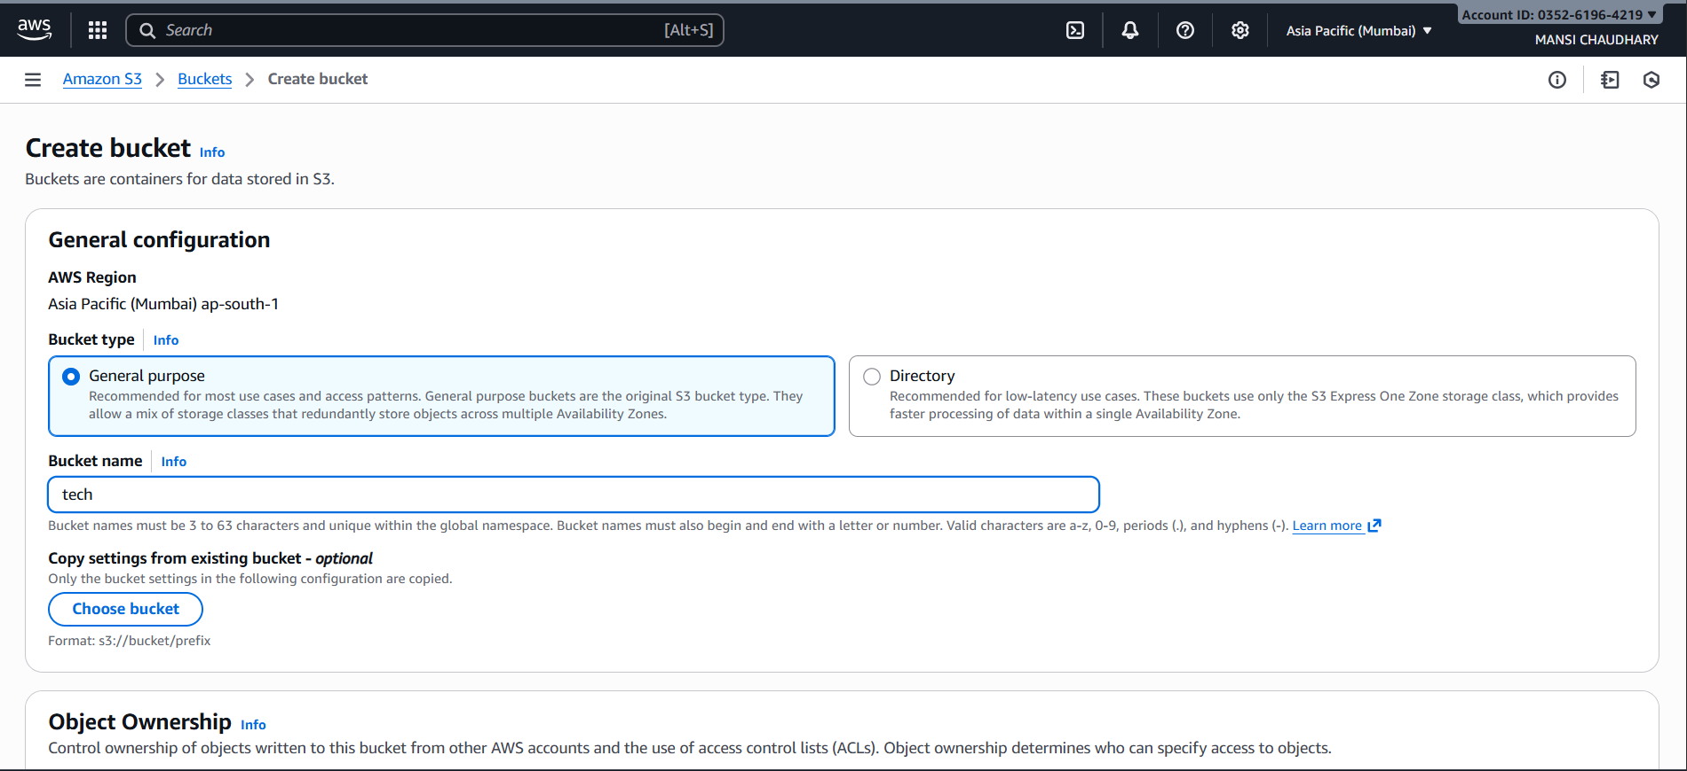
• Region Selected: Asia Pacific (Mumbai) ap-south-1
- Bucket Name: tech
  - Must be globally unique, 3–63 characters, and use only lowercase letters, numbers, periods, or hyphens.
- Bucket Type Options:
  - General Purpose (selected): Recommended for most use cases; supports multiple storage classes across Availability Zones.
  - Directory: Optimized for low-latency access using S3 Express One Zone.
- Optional Settings Copy: Users can replicate settings from an existing bucket using the format s3://bucket/prefix.
- Object Ownership (partially visible): Controls access and ownership of objects, including ACL configurations.

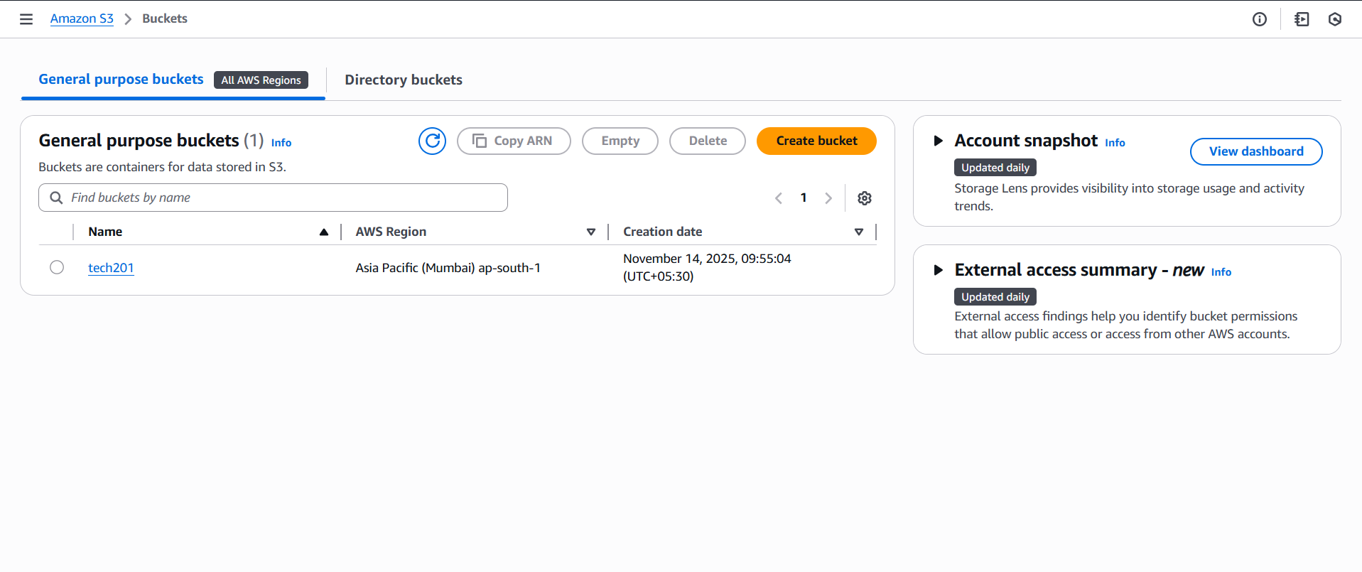
• Bucket Listed: tech201
  - Region: Asia Pacific (Mumbai) ap-south-1
  - Created On: November 14, 2025, 09:55:04 (UTC+05:30)
- Available Actions: Copy ARN, Empty, Delete, Create bucket
- Search & Navigation: Bucket search bar and pagination (Page 1)
- Informational Panels:
- Account Snapshot: Links to dashboard; updated daily via Storage Lens for usage and activity insights.
- External Access Summary (New): Highlights public or cross-account access permissions; updated daily.
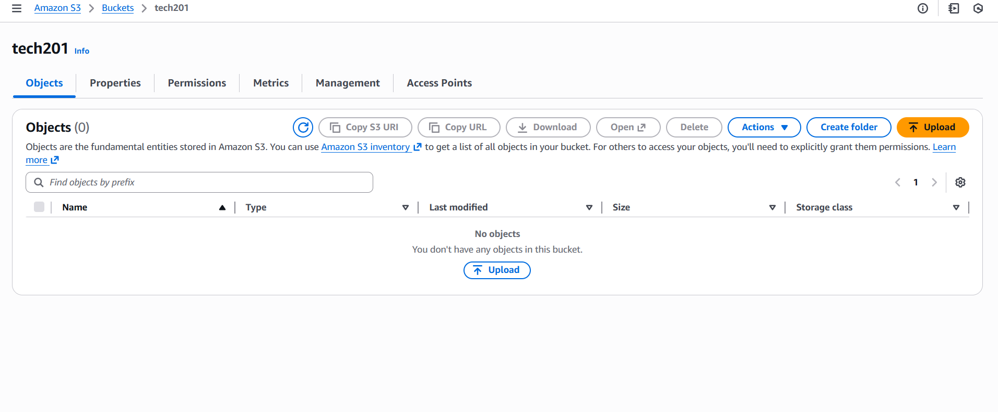
- You are currently on the Objects tab.
- The bucket contains no objects — the list is empty.
- There are options at the top to:
  - Upload files
  - Create folder
  - Copy S3 URI / URL, Download, Open, Delete, and other Actions
- A search bar is available to find objects by prefix, but since there are no objects yet, the table shows:
  - Name
  - Type
  - Last modified
  - Size
  - Storage class
All with no entries.
At the center, it says “No objects” with a button to Upload.
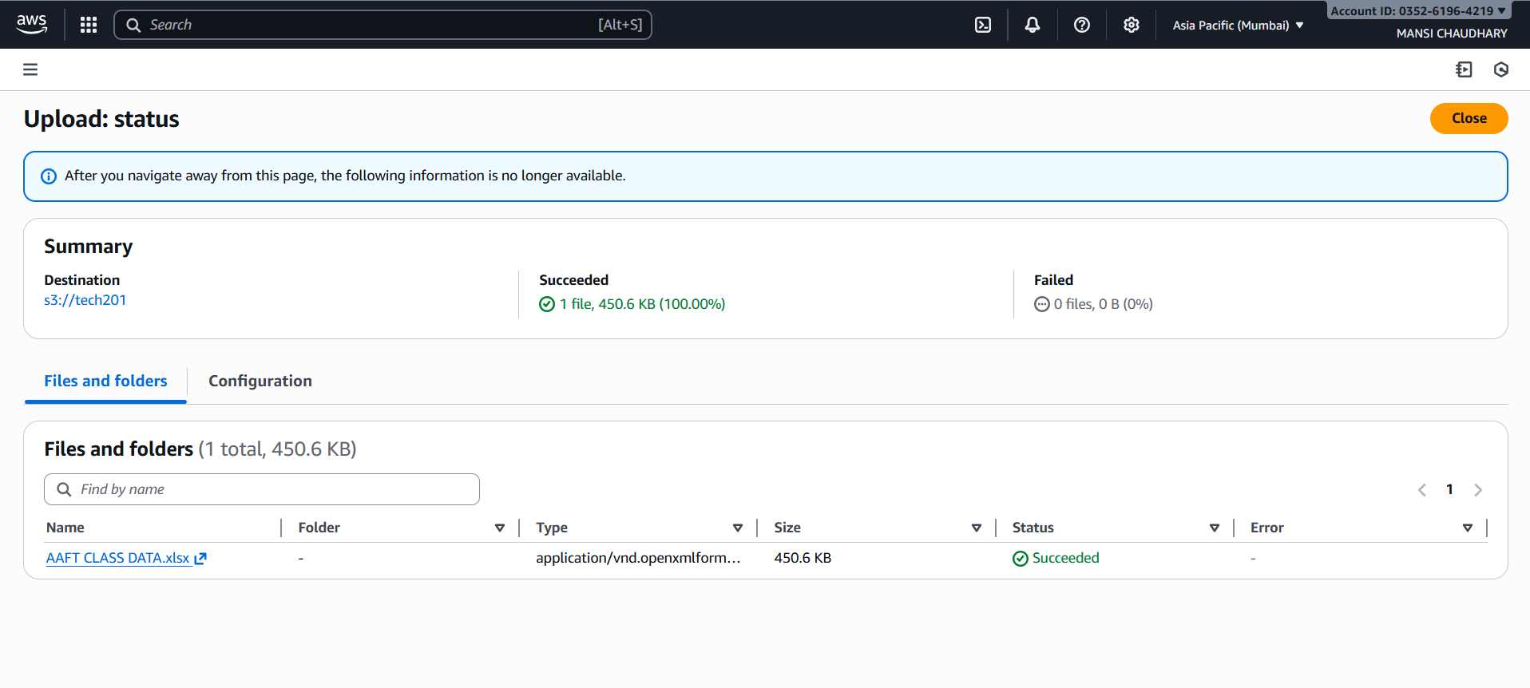
The screenshot shows the Upload Status page in the Amazon S3 console.
It confirms the result of uploading a file to the S3 bucket tech201.
Upload Summary
- Destination: s3://tech201
- Succeeded: 1 file uploaded successfully
  - Total size: 450.6 KB
  - Success rate: 100%
- Failed: 0 files
Uploaded File Details
- File Name: AAFT CLASS DATA.xlsx
- Folder: (None — uploaded to root of the bucket)
- File Type: application/vnd.openxmlformats-officedocument.spreadsheetml.sheet
- Size: 450.6 KB
- Status: Succeeded
- Error: None

